Q1. Check the version of python installed on your system.

**output:-**

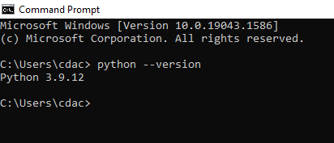

Q2. Initialize different types of variables – int, float, str, complex; then display their type using type() function.

**Output:-** type int 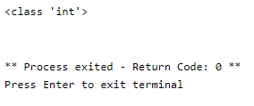

Type float 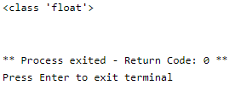

Type str 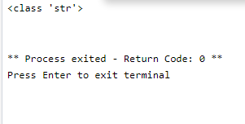

Type complex 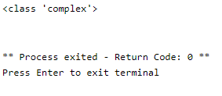

Q3. Declare different numeric literals and display its value.

**Output:-** 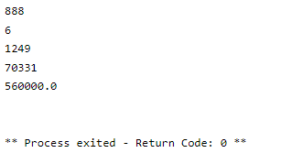

Q4. Write a script to print the following sentences:-

1. How’s everyone!
2. “It’s too cold today.”

**Output:-** 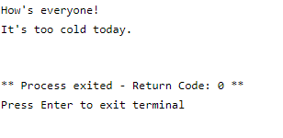

Q5. Write a script to demonstrate use of:-

1. isinstance
2. Chr
3. Ord

**Output:-** 